**FaceBook** & Google API’s

**2014**

1. Go to this <https://apps.facebook.com/ipowerfefcbacd>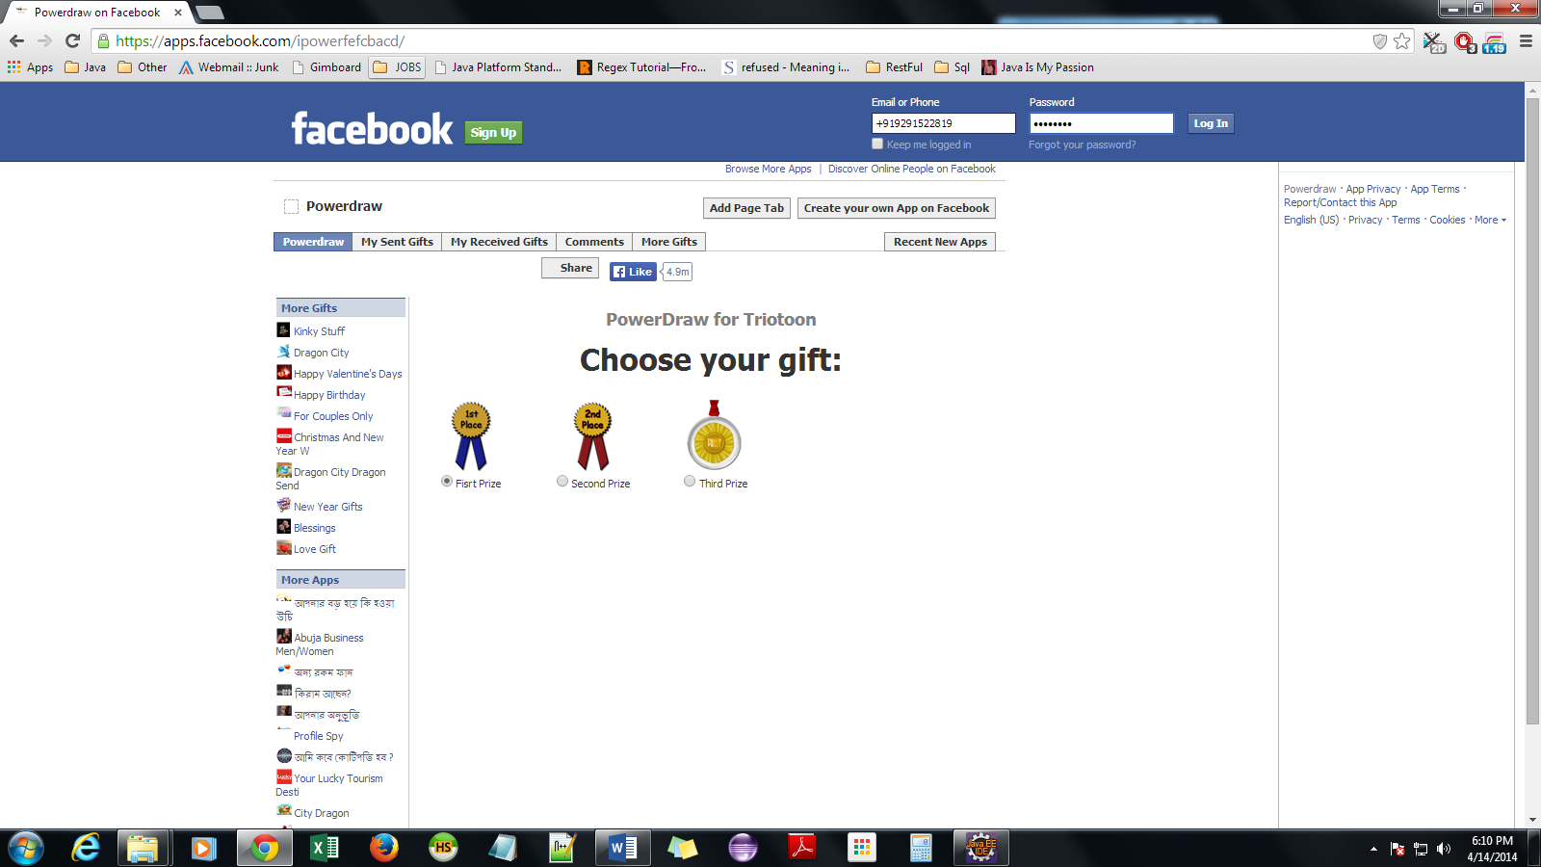
2. Click on create own app on fb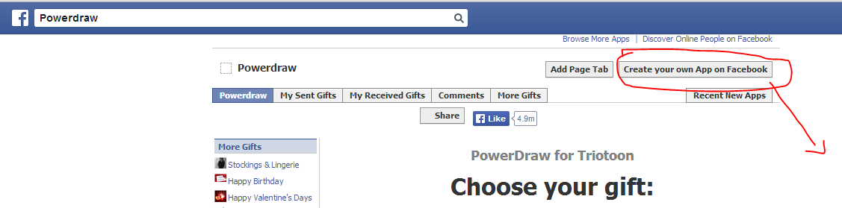
3. Choose one of the app
4. Enter Name, logo,description, questions based up on the App, Choose any one 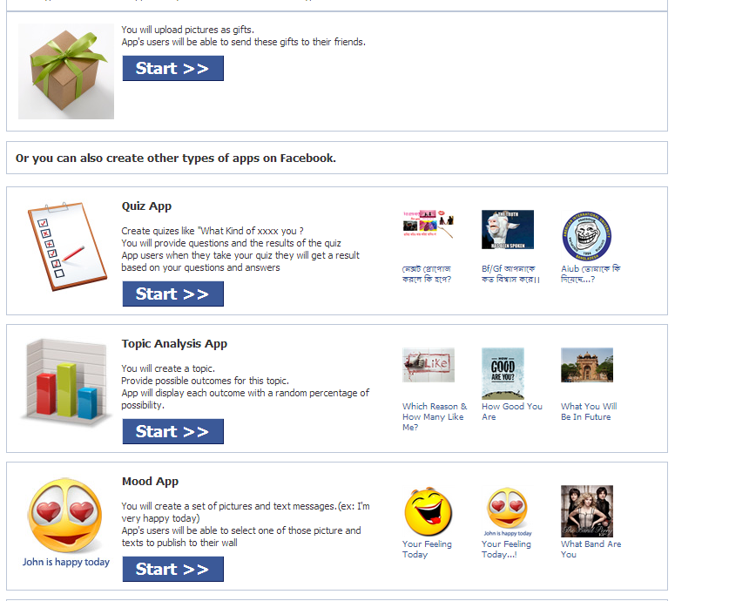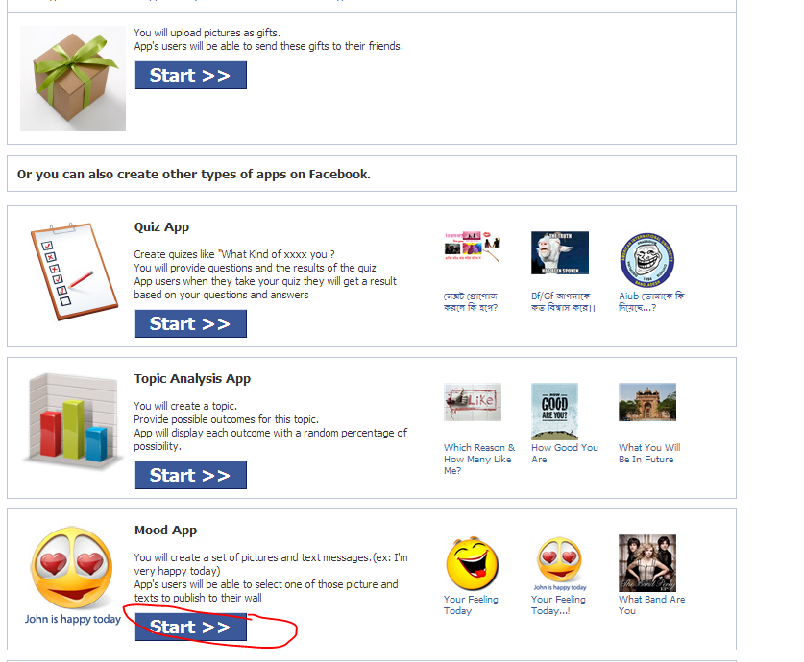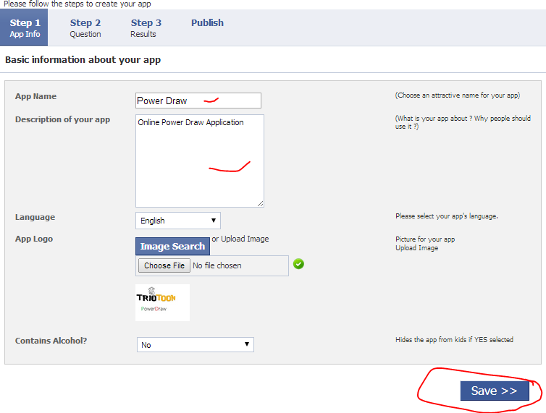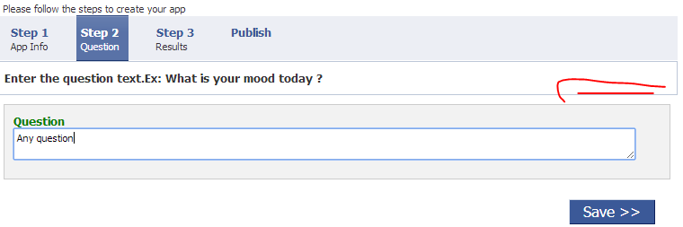
5. Lets Fill atleast one my Self 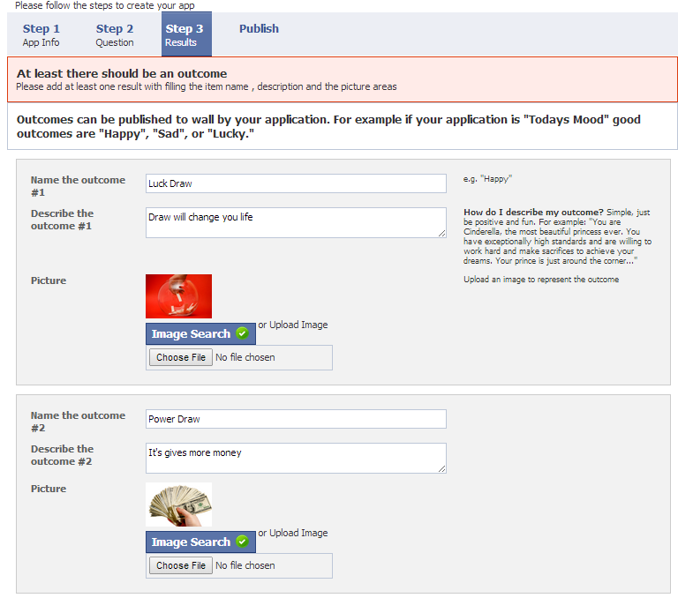
6. On next Screen you may got like 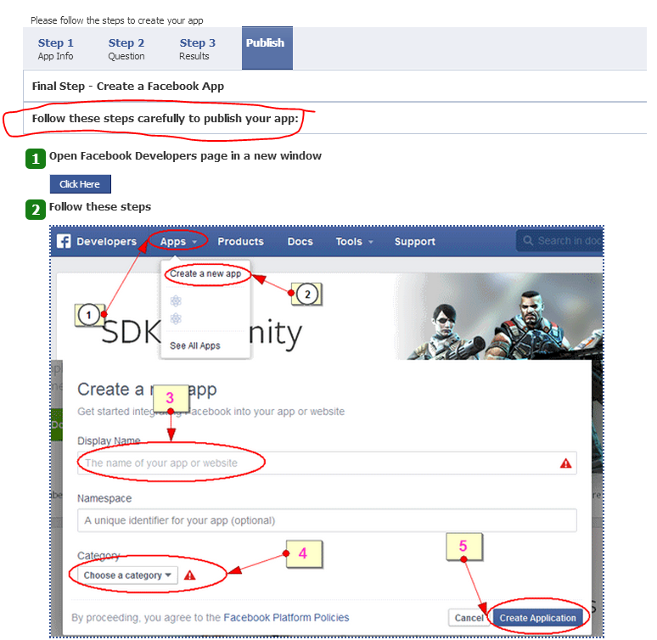
7. 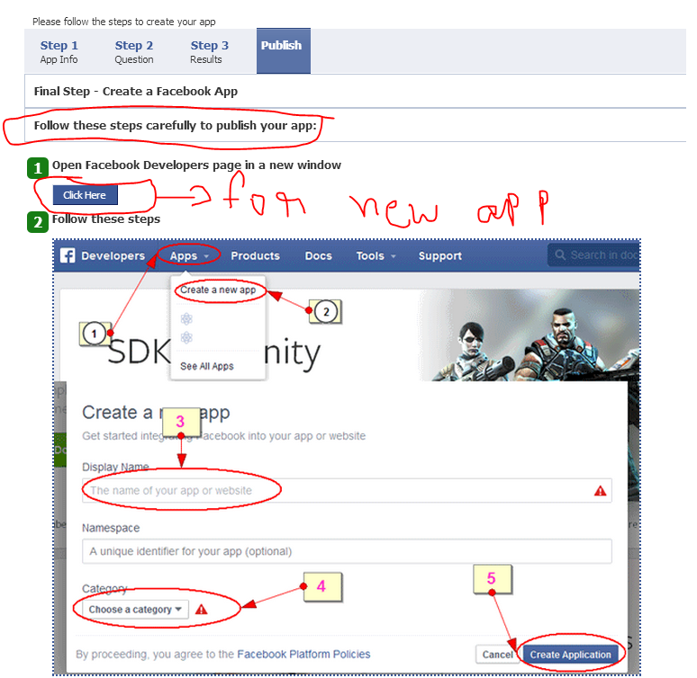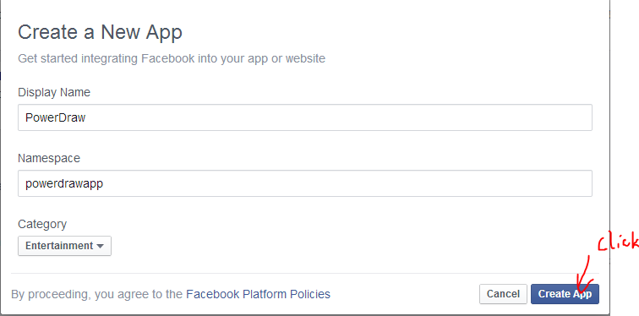
8. Create new App by clicking this, the Dashboard will come like this

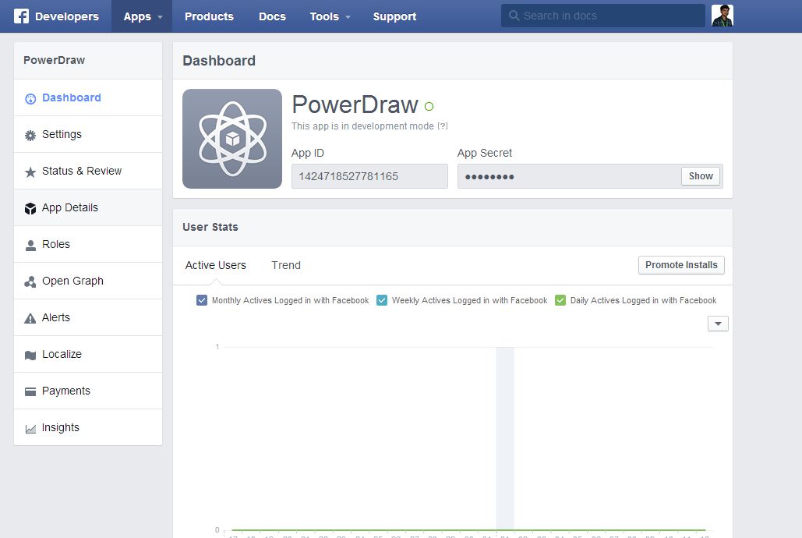

**9. Copy APPID, App Secret Previous Page**

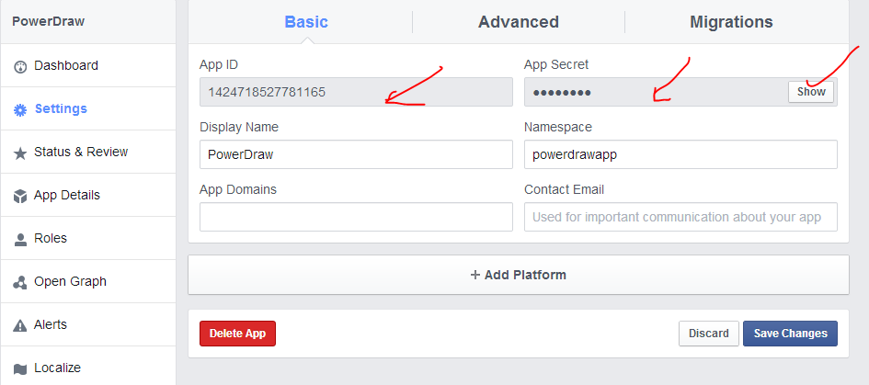

**10. Copy those in App and Publish**

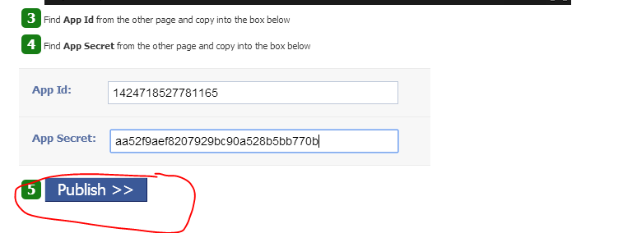

**10. after publish it automatically goes to dash board, then go to Settings and Enter Host Site addresses as App Domains and Website URL as the page what our return in URL project. And also enter Contact mail it is Very Important!**

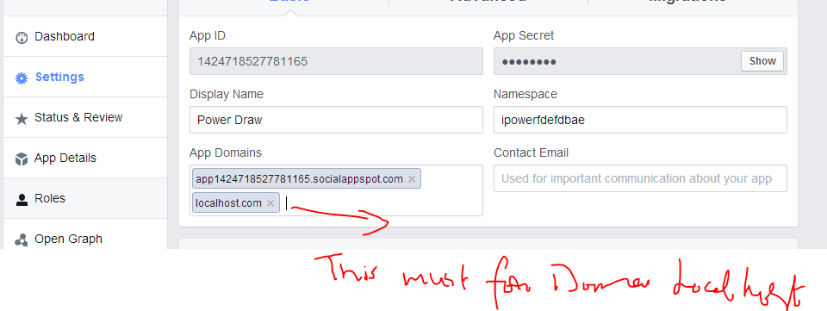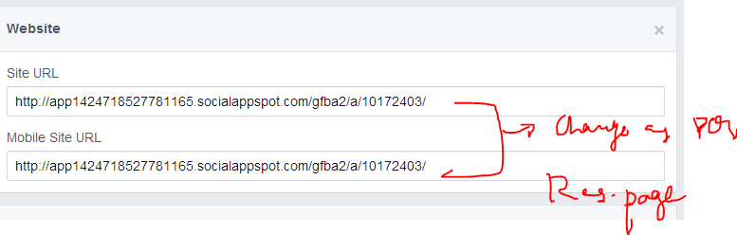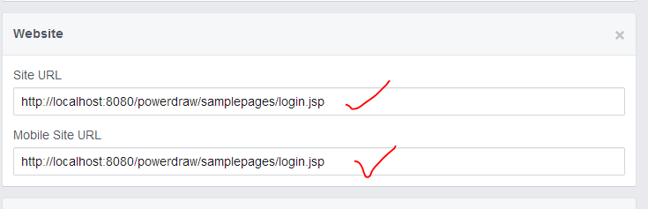

**11. Click on Status & Review and Click PUBLIC On for show your app to all the public can access**

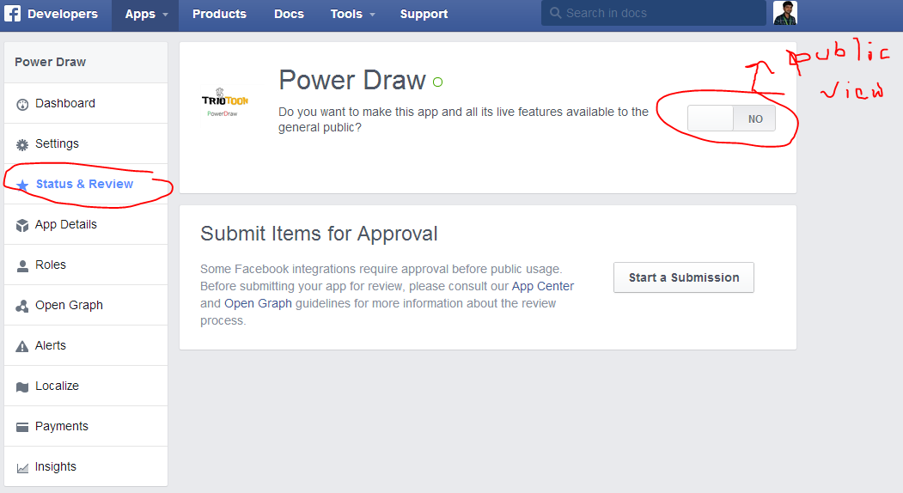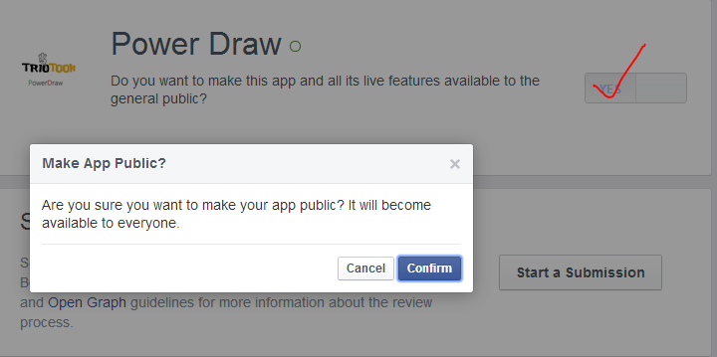

**12. If your app is published to public the GREEN light will Shown**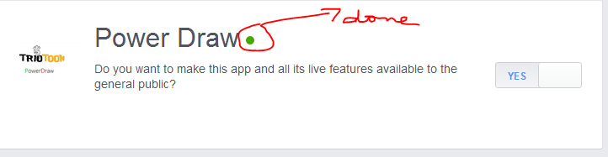

13. Should change in jsp page coding according to face book application settings.

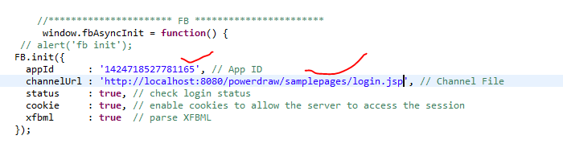

**14. If we want login with facebook click face book.**

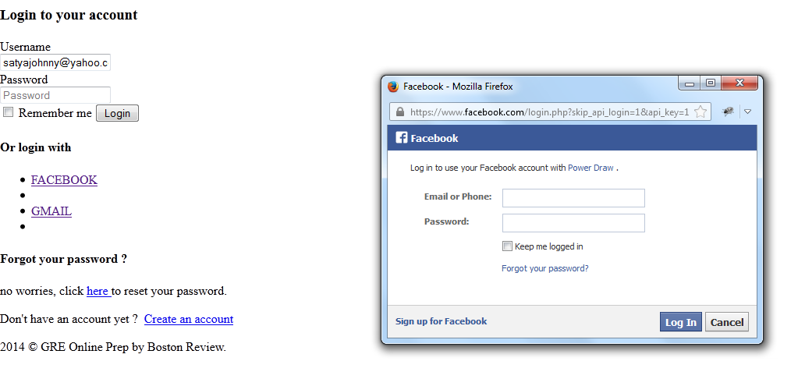

**15. If login correct** 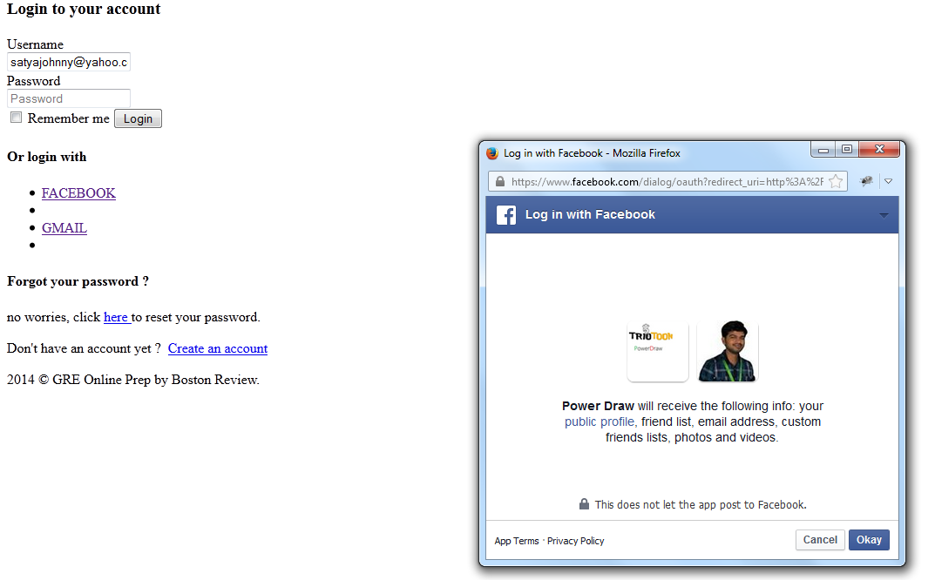

**16. Click ok if you agree ….**

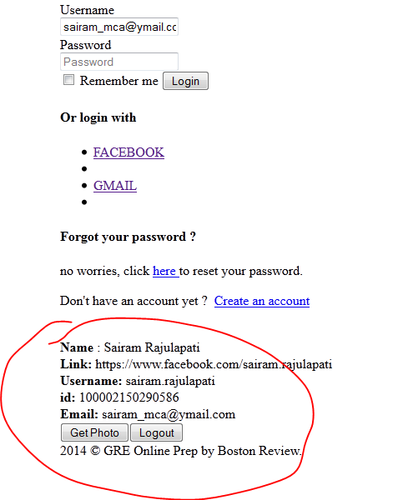

**Gmail Access: ---**

1. **1st go to this link :** [**https://console.developers.google.com/project/apps~polished-parser-550?redirected=true%3Fauthuser&redirected=true**](https://console.developers.google.com/project/apps~polished-parser-550?redirected=true%3Fauthuser&redirected=true)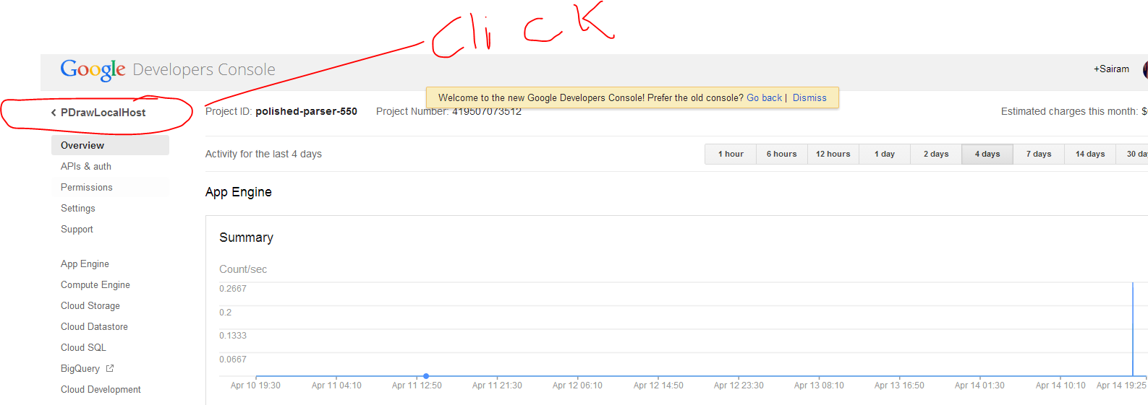
2. **Then after You may got page and click create project** 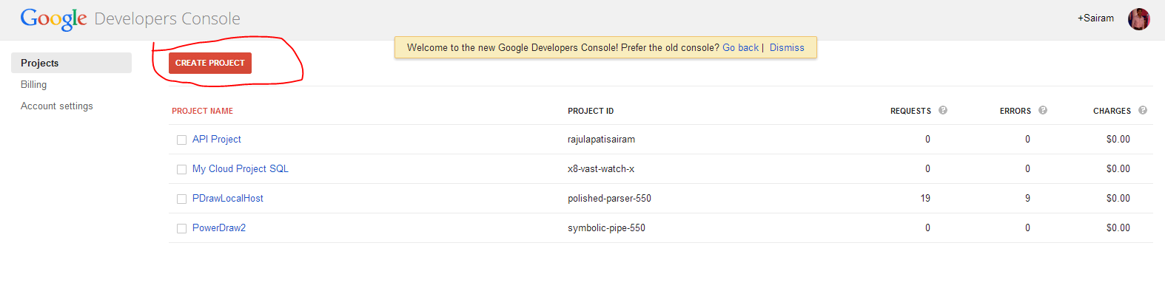
3. **Then after given project with unique project Id** 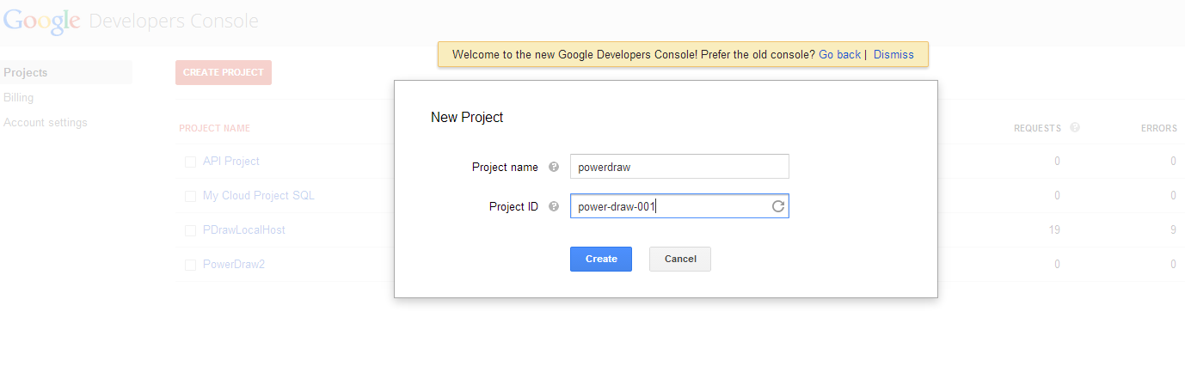
4. **Then it’s navigate to this page then select created project …** 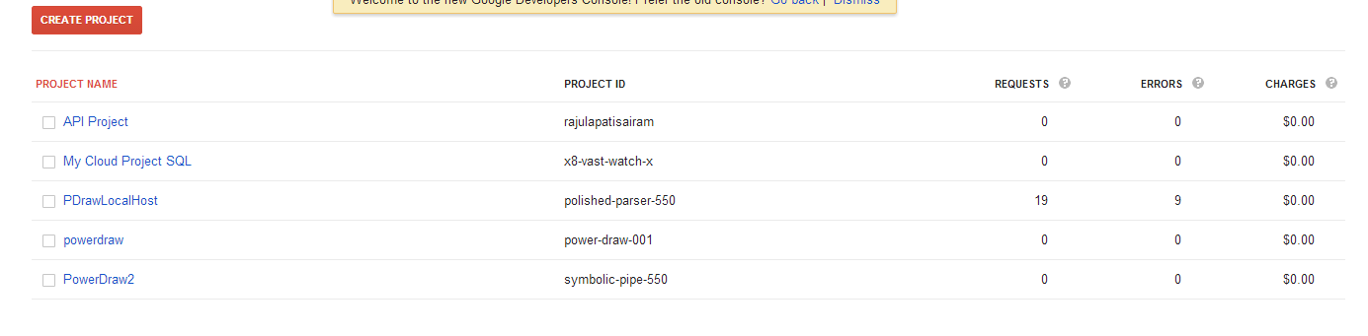
5. **Then select Apps & auth** 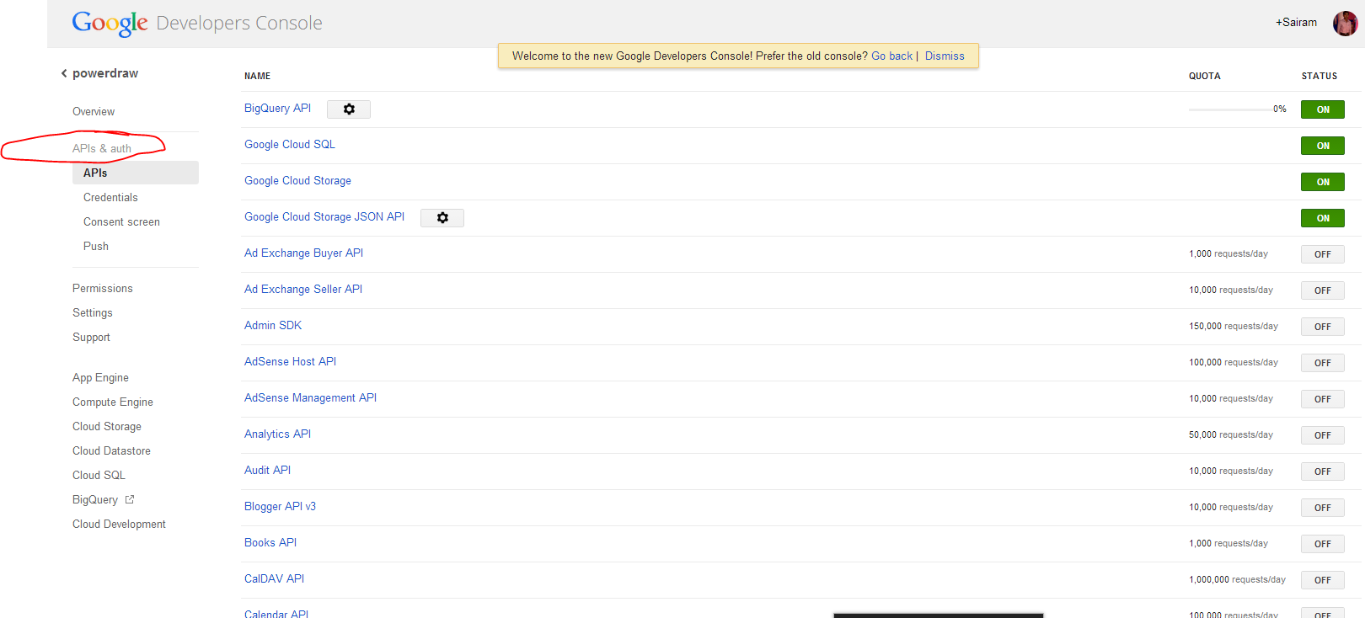
6. **Make required one as on based on your requirements.**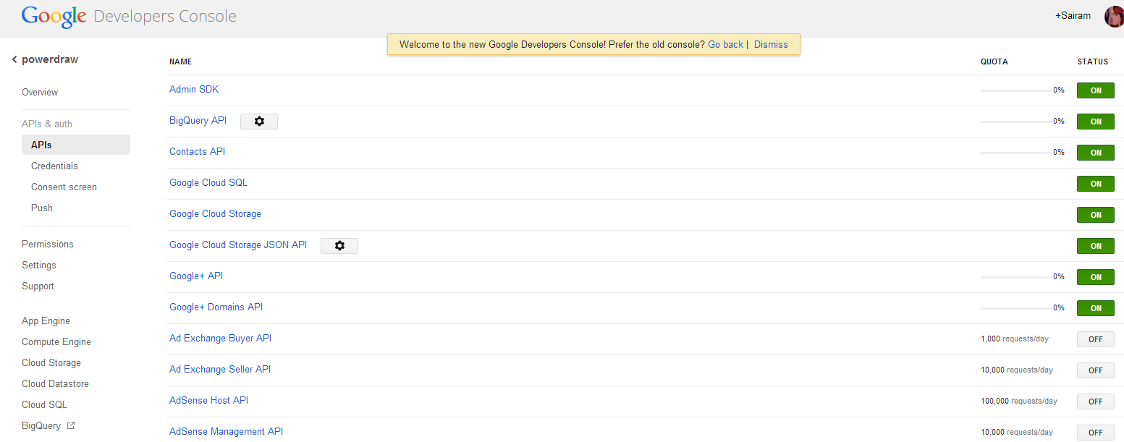
7. **Then choose credentials then after create new key …**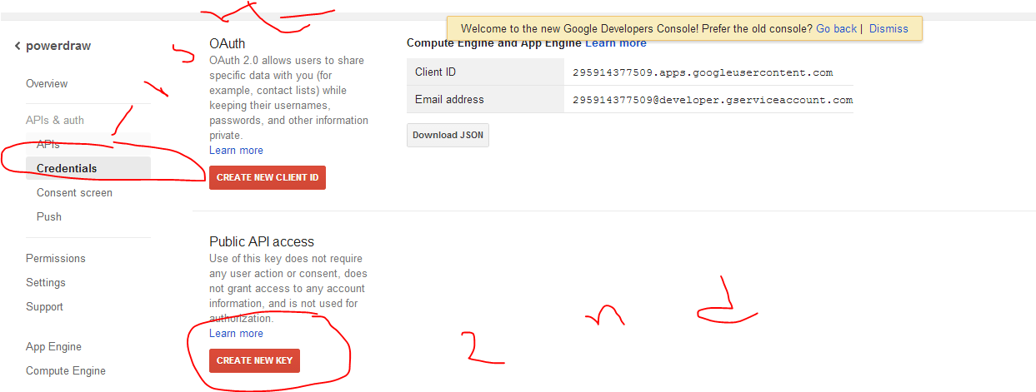
8. **Now we got the key created window then select Browser Key**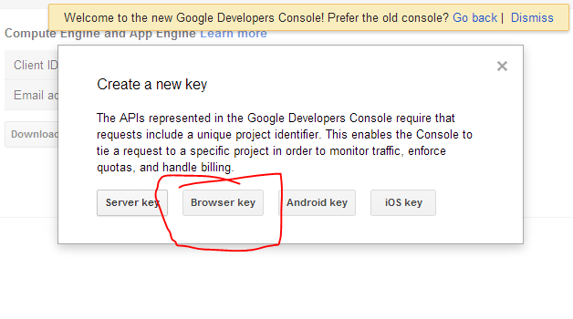
9. **Then it’s ask for website in which we have to integrate the Gmail login :** 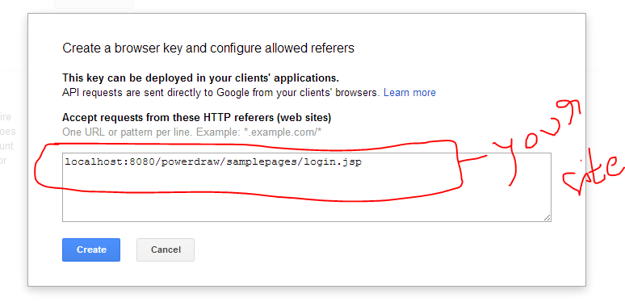
10. **Now we got the new created keys :** 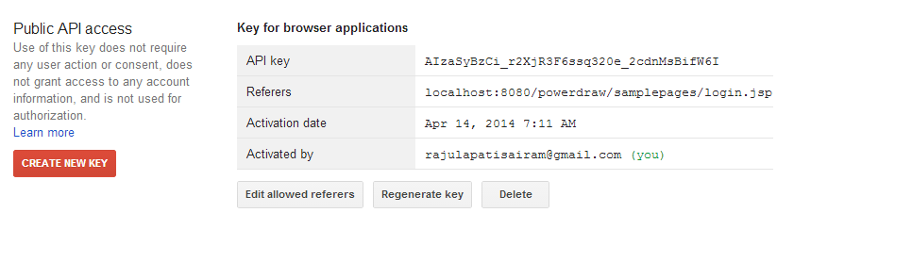
11. **Now we have to create the new client Id :**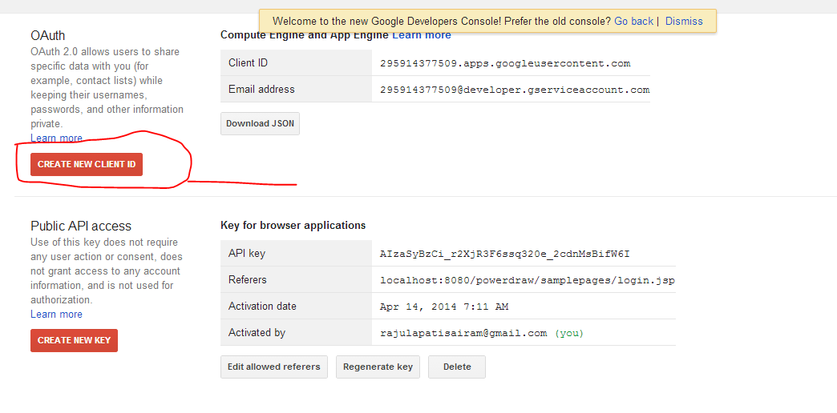
12. **Now we have to give like following** 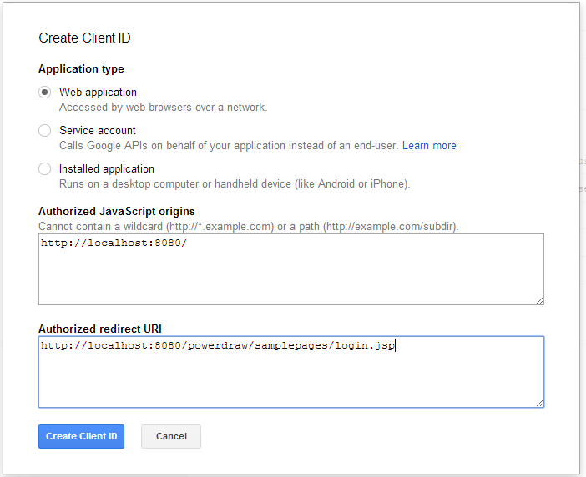
13. **Now we got like following** 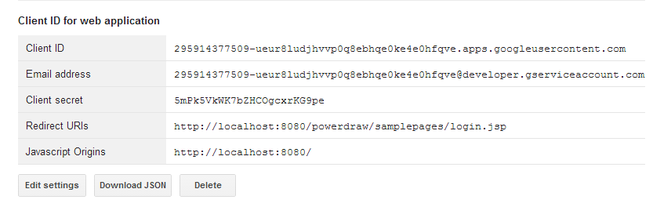
14. **For remaining settings we go for Consent Screen** 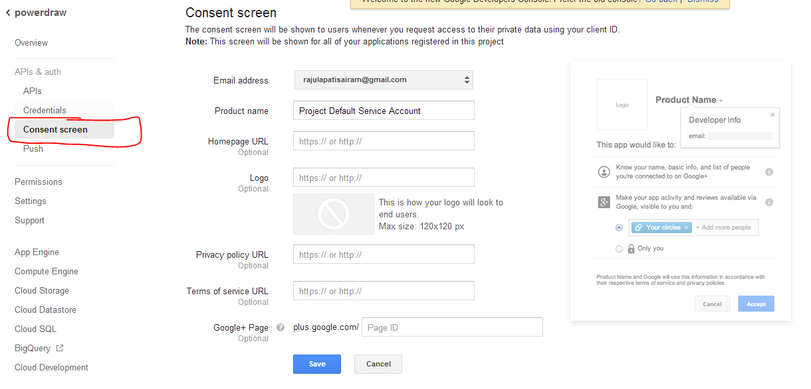
15. **We should give required information** 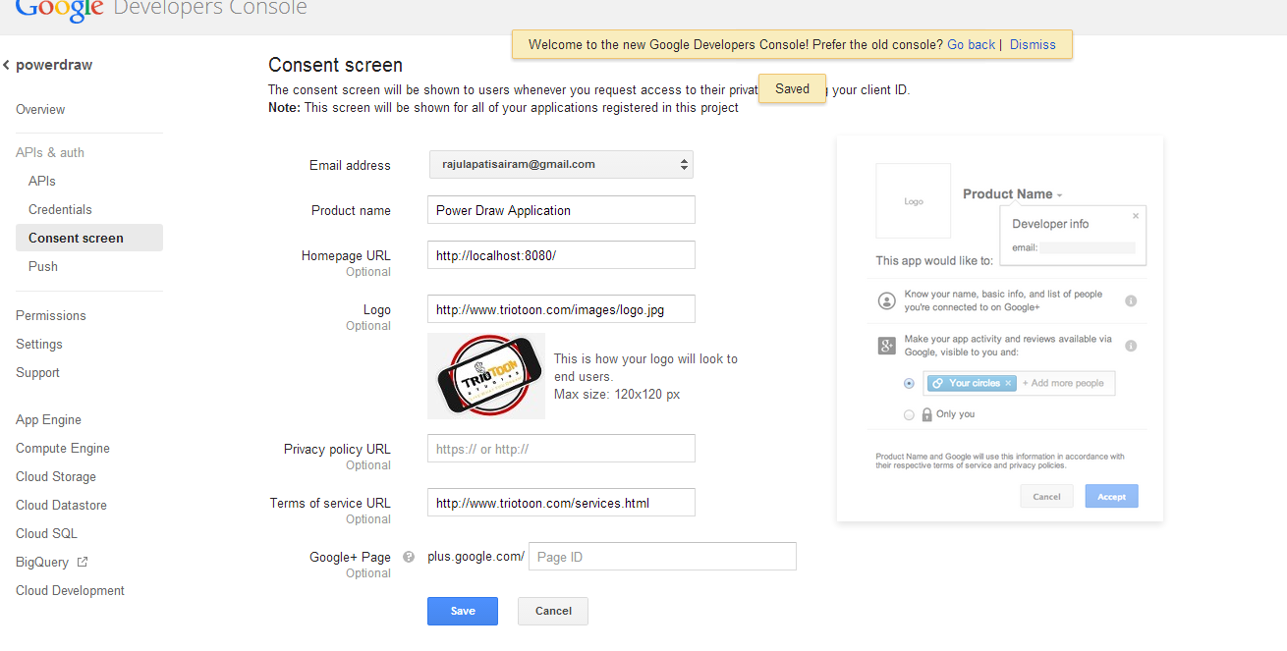
16. **Then after you should change in you jsp code :** 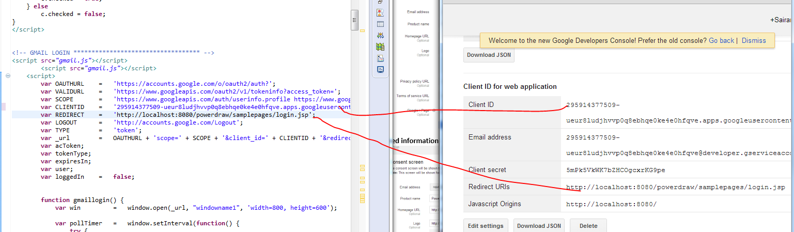
17. **Then after setting just run jsp page then you got Gmail login button then click :** 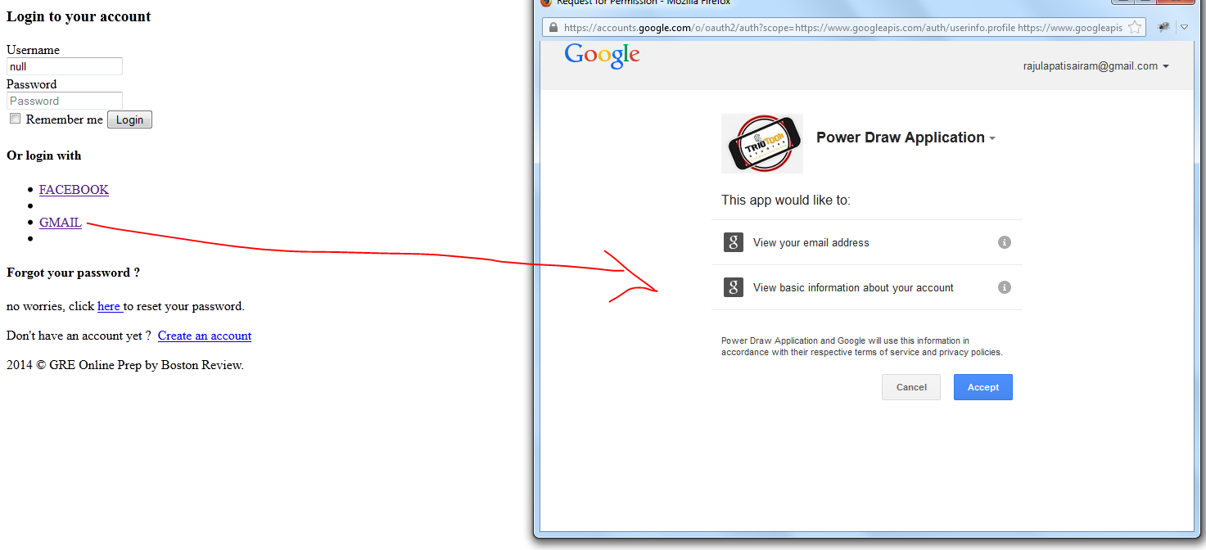
18. **If you enter properly then its login successfully.**
19. **Facebook parameters list :** [**https://developers.facebook.com/docs/facebook-login/permissions/**](https://developers.facebook.com/docs/facebook-login/permissions/)
20. **For Gmail :** [**https://developers.google.com/accounts/docs/OAuth2LoginV1**](https://developers.google.com/accounts/docs/OAuth2LoginV1)
21. **Sample Program :** [**http://stackoverflow.com/questions/10327725/unable-to-get-user-info-after-successfully-logging-with-google-oauth-2-0**](http://stackoverflow.com/questions/10327725/unable-to-get-user-info-after-successfully-logging-with-google-oauth-2-0)
22. [**http://stackoverflow.com/questions/20089623/google-oauth-for-installed-apps-using-javascript**](http://stackoverflow.com/questions/20089623/google-oauth-for-installed-apps-using-javascript)
23. [**https://github.com/valenting/ffos-google-contact-importer/blob/master/index.html**](https://github.com/valenting/ffos-google-contact-importer/blob/master/index.html)

**Code:**

<!DOCTYPEhtmlPUBLIC"-//W3C//DTD XHTML 1.0 Transitional//EN""http://www.w3.org/TR/xhtml1/DTD/xhtml1-transitional.dtd">

<%@taglibprefix=*"s"*uri=*"/struts-tags"*%>

<!--[if IE 8]><html lang="en" class="ie8 no-js"><![endif]-->

<!--[if IE 9]><html lang="en" class="ie9 no-js"><![endif]-->

<!--[if !IE]><!--><htmllang=*"en"*class=*"no-js"*><!-- <![endif]-->

<!-- BEGIN HEAD -->

<head>

<metacharset=*"utf-8"*/>

<title> Login Page</title>

<metahttp-equiv=*"X-UA-Compatible"*content=*"IE=edge"*/>

<metacontent=*"width=device-width, initial-scale=1.0"*name=*"viewport"*/>

<metacontent=*""*name=*"description"*/>

<metacontent=*""*name=*"author"*/>

<metaname=*"MobileOptimized"*content=*"320"*/>

<!-- BEGIN GLOBAL MANDATORY STYLES -->

<!-- BEGIN GLOBAL MANDATORY STYLES -->

<linkhref=*"http://fonts.googleapis.com/css?family=Open+Sans:400,300,600,700&subset=all"*rel=*"stylesheet"*type=*"text/css"*/>

<linkhref=*"assets/plugins/font-awesome/css/font-awesome.min.css"*rel=*"stylesheet"*type=*"text/css"*/>

<linkhref=*"assets/plugins/bootstrap/css/bootstrap.min.css"*rel=*"stylesheet"*type=*"text/css"*/>

<linkhref=*"assets/plugins/uniform/css/uniform.default.css"*rel=*"stylesheet"*type=*"text/css"*/>

<!-- END GLOBAL MANDATORY STYLES -->

<!-- BEGIN PAGE LEVEL STYLES -->

<linkrel=*"stylesheet"*type=*"text/css"*href=*"assets/plugins/select2/select2.css"*/>

<linkrel=*"stylesheet"*type=*"text/css"*href=*"assets/plugins/select2/select2-metronic.css"*/>

<!-- END PAGE LEVEL SCRIPTS -->

<!-- BEGIN THEME STYLES -->

<linkhref=*"assets/css/style-metronic.css"*rel=*"stylesheet"*type=*"text/css"*/>

<linkhref=*"assets/css/style.css"*rel=*"stylesheet"*type=*"text/css"*/>

<linkhref=*"assets/css/style-responsive.css"*rel=*"stylesheet"*type=*"text/css"*/>

<linkhref=*"assets/css/plugins.css"*rel=*"stylesheet"*type=*"text/css"*/>

<linkhref=*"assets/css/themes/default.css"*rel=*"stylesheet"*type=*"text/css"*id=*"style_color"*/>

<linkhref=*"assets/css/pages/login.css"*rel=*"stylesheet"*type=*"text/css"*/>

<linkhref=*"assets/css/custom.css"*rel=*"stylesheet"*type=*"text/css"*/>

<script>

**function** remember_me() {

**var** c = $("#check"); //INPUT CHECKBOX

//IF CHECKBOX IS SET, COOKIE WILL BE SET

**if** (c.is(":checked")) {

**var** u = $("#email").val(); //VALUE OF USERNAME

**var** p = $("#pwd").val(); //VALUE OF PASSWORD

$.cookie("email", u, {

expires : 3

}); //SETS IN DAYS (10 YEARS)

$.cookie("pwd", p, {

expires : 3

}); //SETS IN DAYS (10 YEARS)

} **else** {

$.cookie("email", "", {

expires : 3

}); //Removing Cookies

$.cookie("pwd", "", {

expires : 3

}); //Removing Cookies

}

}

//NEXT PAGE LOAD, THE USERNAME & PASSWORD WILL BE SHOWN IN THEIR FIELDS

**function** load_em() {

**var** u = $.cookie("email"); //"USERNAME" COOKIE

**var** p = $.cookie("pwd"); //"PASSWORD" COOKIE

$("#email").val(u); //FILLS WITH "USERNAME" COOKIE

$("#pwd").val(p); //FILLS WITH "PASSWORD" COOKIE

**if** (p.length > 0) {

**var** c = document.getElementById("check");

c.checked = **true**;

} **else**

c.checked = **false**;

}

</script>

<!-- GMAIL LOGIN *********************************** -->

<scriptsrc=*"gmail.js"*></script>

<scriptsrc=*"gmail.js"*></script>

<script>

**var** OAUTHURL = 'https://accounts.google.com/o/oauth2/auth?';

**var** VALIDURL = 'https://www.googleapis.com/oauth2/v1/tokeninfo?access_token=';

**var** SCOPE = 'https://www.googleapis.com/auth/userinfo.profile https://www.googleapis.com/auth/userinfo.email';

**var** CLIENTID = '419507073512-odaebk8u6n0fhmvc4d5akah33ljecic4.apps.googleusercontent.com';

**var** REDIRECT = 'http://localhost:8080/powerdraw/samplepages/login.jsp';

**var** LOGOUT = 'http://accounts.google.com/Logout';

**var** TYPE = 'token';

**var** _url = OAUTHURL + 'scope=' + SCOPE + '&client_id=' + CLIENTID + '&redirect_uri=' + REDIRECT + '&response_type=' + TYPE;

**var** acToken;

**var** tokenType;

**var** expiresIn;

**var** user;

**var** loggedIn = **false**;

**function** gmaillogin() {

**var** win = window.open(_url, "windowname1", 'width=800, height=600');

**var** pollTimer = window.setInterval(**function**() {

**try** {

console.log(win.document.URL);

**if** (win.document.URL.indexOf(REDIRECT) != -1) {

window.clearInterval(pollTimer);

**var** url = win.document.URL;

acToken = gup(url, 'access_token');

tokenType = gup(url, 'token_type');

expiresIn = gup(url, 'expires_in');

win.close();

validateToken(acToken);

}

} **catch**(e) {

}

}, 500);

}

**function** validateToken(token) {

$.ajax({

url: VALIDURL + token,

data: **null**,

success: **function**(responseText){

getGmailInfo();

loggedIn = **true**;

$('#logoutText').show();

},

dataType: "jsonp"

});

}

**function** getGmailInfo() {

$.ajax({

url: 'https://www.googleapis.com/oauth2/v1/userinfo?access_token=' + acToken,

data: **null**,

success: **function**(resp) {

user = resp;

console.log(user);

$('#email').text(user.email);

**var** fb = user.email;

document.getElementById("fb").innerHTML=fb;

document.getElementById("emailid").value=fb;

**if**(fb.indexOf("a")>0 && fb.length>0)

{

document.getElementById("social").value = "true";

//alert('Im TRUE GMAIL '+ document.getElementById("social").value);

actions();

}

},

dataType: "jsonp"

});

}

//credits: http://www.netlobo.com/url_query_string_javascript.html

**function** gup(url, name) {

name = name.replace(/[\[]/,"\\\[").replace(/[\]]/,"\\\]");

**var** regexS = "[\\#&]"+name+"=([^&#]*)";

**var** regex = **new** RegExp( regexS );

**var** results = regex.exec( url );

**if**( results == **null** )

**return**"";

**else**

**return** results[1];

}

**function** startLogoutPolling() {

$('#logoutText').hide();

loggedIn = **false**;

}

//********************** FB ***********************

window.fbAsyncInit = **function**() {

// alert('fb init');

FB.init({

appId : '1424718527781165', // App ID

channelUrl : 'http://localhost:8080/powerdraw/samplepages/login.jsp', // Channel File

status : **true**, // check login status

cookie : **true**, // enable cookies to allow the server to access the session

xfbml : **true**// parse XFBML

});

FB.Event.subscribe('auth.authResponseChange', **function**(response)

{

**if** (response.status === 'connected')

{

document.getElementById("message").innerHTML += "<br>Connected to Facebook";

//SUCCESS

}

**elseif** (response.status === 'not_authorized')

{

document.getElementById("message").innerHTML += "<br>Failed to Connect";

//FAILED

} **else**

{

document.getElementById("message").innerHTML += "<br>Logged Out";

//UNKNOWN ERROR

}

});

};

**function** fblogin()

{

// alert('login');

FB.login(**function**(response) {

**if** (response.authResponse)

{

getUserInfo();

} **else**

{

console.log('User cancelled login or did not fully authorize.');

}

},{scope: 'email,user_photos,user_videos,read_friendlists'});

}

**function** getUserInfo() {

FB.api('/me', **function**(response) {

**var** str="<b>Name</b> : "+response.name+"<br>";

str +="<b>Link: </b>"+response.link+"<br>";

str +="<b>Username:</b> "+response.username+"<br>";

str +="<b>id: </b>"+response.id+"<br>";

str +="<b>Email:</b> "+response.email+"<br>";

str +="<input type='button' value='Get Photo' onclick='getPhoto();'/>";

str +="<input type='button' value='Logout' onclick='Logout();'/>";

document.getElementById("status").innerHTML=str;

**var** fb = response.email;

document.getElementById("fb").innerHTML=fb;

document.getElementById("emailid").value=fb;

**if**(fb.indexOf("a")>0 && fb.length>0)

{

document.getElementById("social").value = "true";

//alert('Im TRUE : '+ document.getElementById("social").value);

actions();

}

//emailid

});

}

**function** getPhoto()

{

FB.api('/me/picture?type=normal', **function**(response) {

**var** str="<br/><b>Pic</b> : <img src='"+response.data.url+"'/>";

document.getElementById("status").innerHTML+=str;

});

}

**function** Logout()

{

FB.logout(**function**(){document.location.reload();});

}

// Load the SDK asynchronously

(**function**(d){

**var** js, id = 'facebook-jssdk', ref = d.getElementsByTagName('script')[0];

**if** (d.getElementById(id)) {**return**;}

js = d.createElement('script'); js.id = id; js.async = **true**;

js.src = "//connect.facebook.net/en_US/all.js";

ref.parentNode.insertBefore(js, ref);

}(document));

**function** actions(){

/* //alert('From action --> FLAG : '+ document.getElementById("social").value+' Email: '+document.getElementById("emailid").value); */

**var** formInput=$('#form1').serialize();

$.ajax({

type :"post",

url :"login1.action",

data:formInput,

success:**function**(response){

//alert(response);

**if**(response){

// toastr.success('Deleted Successfully');

//alert(response);

$("body").html(response);

// App.init();

Login();

}

},

error:**function**(e){

}

});

//App.init();

//Login.init();

//bootbox.alert("Error : "+e);

}//actions aend

</script>

</head>

<!-- BEGIN BODY -->

<bodyclass=*"login"*>

<!-- BEGIN LOGO -->

<divclass=*"logo"*>

<ahref=*"index.html"*>

<imgsrc=*"assets/img/logo-big.png"*alt=*""*/>

</a>

</div>

<!-- BEGIN BODY -->

<divclass=*"content"*>

<!-- BEGIN LOGIN FORM -->

<formclass=*"login-form"*name=*"login"*method=*"post"*id=*"form1"*action=*"login1.action"*>

<%**if**(request.getAttribute("successMessage")!=**null**) { %>

<divclass=*"alert alert-success display-show"*>

<buttonclass=*"close"*data-dismiss=*"alert"*></button>

<p><%=request.getAttribute("successMessage") %></p>

</div>

<%} %>

<%**if**(request.getAttribute("errorMessage")!=**null**) { %>

<divclass=*"alert alert-danger display-show"*>

<buttonclass=*"close"*data-dismiss=*"alert"*></button>

<p><%=request.getAttribute("errorMessage") %></p>

</div>

<%} %>

<h3class=*"form-title"*>Login to your account</h3>

<div></div>

<divclass=*"form-group"*>

<!--ie8, ie9 does not support html5 placeholder, so we just show field title for that-->

<labelclass=*"control-label visible-ie8 visible-ie9"*>Username</label>

<divclass=*"input-icon"*>

<iclass=*"icon-user"*></i>

<inputtype=*"email"*class=*"form-control placeholder-no-fix"*id=*"emailid"*placeholder=*"Email"*name=*"userBo.email"*required=*"true"*value=*"*<%=request.getAttribute("emailid") %>*"*/>

</div>

</div>

<divclass=*"form-group"*>

<labelclass=*"control-label visible-ie8 visible-ie9"*>Password</label>

<divclass=*"input-icon"*>

<iclass=*"icon-lock"*></i><inputtype=*"password"*class=*"form-control placeholder-no-fix"*id=*"inputPassword12"*minLength=*"8"*maxlength=*"16"*placeholder=*"Password"*name=*"userBo.password"*required=*"true"*/>

</div>

</div>

<!-- <div class="form-actions">

<label class="checkbox" style="padding-left:0px">

<input type="checkbox" name="check" id="check" value="1" /> Remember me

</label>

<button type="submit" id="loginButton" onclick="return remember_me()" class="btn green pull-right" ">

Login <i class="m-icon-swapright m-icon-white"></i>

</button>

</div> -->

<divclass=*"form-actions"*>

<labelclass=*"checkbox"*>

<inputid=*"check"*type=*"checkbox"*name=*"remember"*value=*"1"*/> Remember me </label>

<buttontype=*"submit"*id=*"loginButton"*onclick="return remember_me()"class=*"btn green pull-right"*">

Login <iclass=*"m-icon-swapright m-icon-white"*></i>

</button>

</div>

<divclass=*"login-options"*>

<h4>Or login with</h4>

<ulclass=*"social-icons"*>

<li>

<aclass=*"facebook"*data-original-title=*"facebook"*href=*"#"*onclick="fblogin()">FACEBOOK

</a>

</li>

<li>

<aclass=*"twitter"*data-original-title=*"Twitter"*href=*"#"*>

</a>

</li>

<li>

<aclass=*"googleplus"*data-original-title=*"Goole Plus"*href=*"#"*onclick="gmaillogin();">GMAIL

</a>

</li>

<li>

<aclass=*"linkedin"*data-original-title=*"Linkedin"*href=*"#"*>

</a>

</li>

</ul>

</div>

<divclass=*"forget-password"*>

<h4>Forgot your password ?</h4>

<p>

no worries, click

<ahref=*"forgotpassword.action"*id=*"forget-password"*>

here

</a>

to reset your password.

</p>

</div>

<divclass=*"create-account"*>

<p>

Don't have an account yet ?&nbsp;

<ahref=*"signup.action"*id=*"register-btn"*>

Create an account

</a>

</p>

</div>

<divid=*"fb"*style="visibility: *hidden*;"></div>

<divid=*"status"*></div>

<divid=*'email'*style="visibility: *hidden*;"></div>

<iframename=*'myIFrame'*id=*"myIFrame"*style='display:*none*'></iframe>

<inputtype=*"hidden"*id=*"social"*value=*"false"*name=*"userBo.social"*></input>

</form>

</div>

<!-- BEGIN COPYRIGHT -->

<divclass=*"copyright"*>

2014 &copy; GRE Online Prep by Boston Review.

</div>

<!-- END COPYRIGHT -->

<!-- END LOGIN -->

<!-- BEGIN JAVASCRIPTS(Load javascripts at bottom, this will reduce page load time) -->

<!-- BEGIN CORE PLUGINS -->

<!--[if lt IE 9]>

<script src="css2/assets/plugins/respond.min.js"></script>

<script src="css2/assets/plugins/excanvas.min.js"></script>

<![endif]-->

<scriptsrc=*"assets/plugins/jquery-1.10.2.min.js"*type=*"text/javascript"*></script>

<scriptsrc=*"assets/plugins/jquery-migrate-1.2.1.min.js"*type=*"text/javascript"*></script>

<scriptsrc=*"assets/plugins/bootstrap/js/bootstrap.min.js"*type=*"text/javascript"*></script>

<scriptsrc=*"assets/plugins/bootstrap-hover-dropdown/bootstrap-hover-dropdown.min.js"*type=*"text/javascript"*></script>

<scriptsrc=*"assets/plugins/jquery-slimscroll/jquery.slimscroll.min.js"*type=*"text/javascript"*></script>

<scriptsrc=*"assets/plugins/jquery.blockui.min.js"*type=*"text/javascript"*></script>

<scriptsrc=*"assets/plugins/jquery.cokie.min.js"*type=*"text/javascript"*></script>

<scriptsrc=*"assets/plugins/uniform/jquery.uniform.min.js"*type=*"text/javascript"*></script>

<!-- END CORE PLUGINS -->

<!-- BEGIN PAGE LEVEL PLUGINS -->

<!-- BEGIN PAGE LEVEL PLUGINS -->

<!-- END PAGE LEVEL PLUGINS -->

<!-- BEGIN PAGE LEVEL SCRIPTS -->

<scriptsrc=*"assets/scripts/core/app.js"*></script>

<script>

jQuery(document).ready(**function**() {

// initiate layout and plugins

App.init();

**if**($('#emailid').val()=='null')

{

//alert('ok');

$('#emailid').val('');

}

Login();

FormWizard.init();

});

</script>

<!-- END JAVASCRIPTS -->

</body>

<!-- END BODY -->

</html>